Name

Mathematics Extension 1 Year 12
Multiplicity of Zeroes

Book 1 |  | Version: 250928  Feedback:  https://MrDingMaths.com
Contents
Syllabus Content 2
Learning Intention Error! Bookmark not defined.

Syllabus Content
ME1-12-05 applies calculus to solve problems involving polynomials, further rates of change, areas and volumes and differential equations
Multiplicity of zeroes of polynomial functions
- Use the product rule to prove that if $P\left(x\right)$ has a zero, $α$, of multiplicity $m>1$, then $α$ is a zero of $P'(x)$ of multiplicity $m-1$, and use the result to determine the multiplicity of a discovered zero of $P(x)$ and solve related polynomial problems
- Prove that if $α$ is a zero of multiplicity $m$, meeting the $x$-axis at $A(α,0)$, then if $m=1$, the curve crosses the $x$-axis at $A$ at an acute or obtuse angle; if $m>1$ is even, the curve is tangent to the $x$-axis at $A$ and does not cross it; if $m>1$ is odd, the curve has a horizontal inflection at $A$
- Graph a polynomial function in factored form, identifying its turning points and points of inflection if possible, and explore its behaviour as $x→∞$ and $x→-∞$, verifying the shape of the graph using graphing applications

Roots of Multiplicity

- Review
- Sketch polynomials with multiple roots.
- $y=\left(x-3\right){\left(x+1\right)}^{2}$ | - $y=-{\left(x+1\right)}^{3}\left(x-1\right)(x-3)$  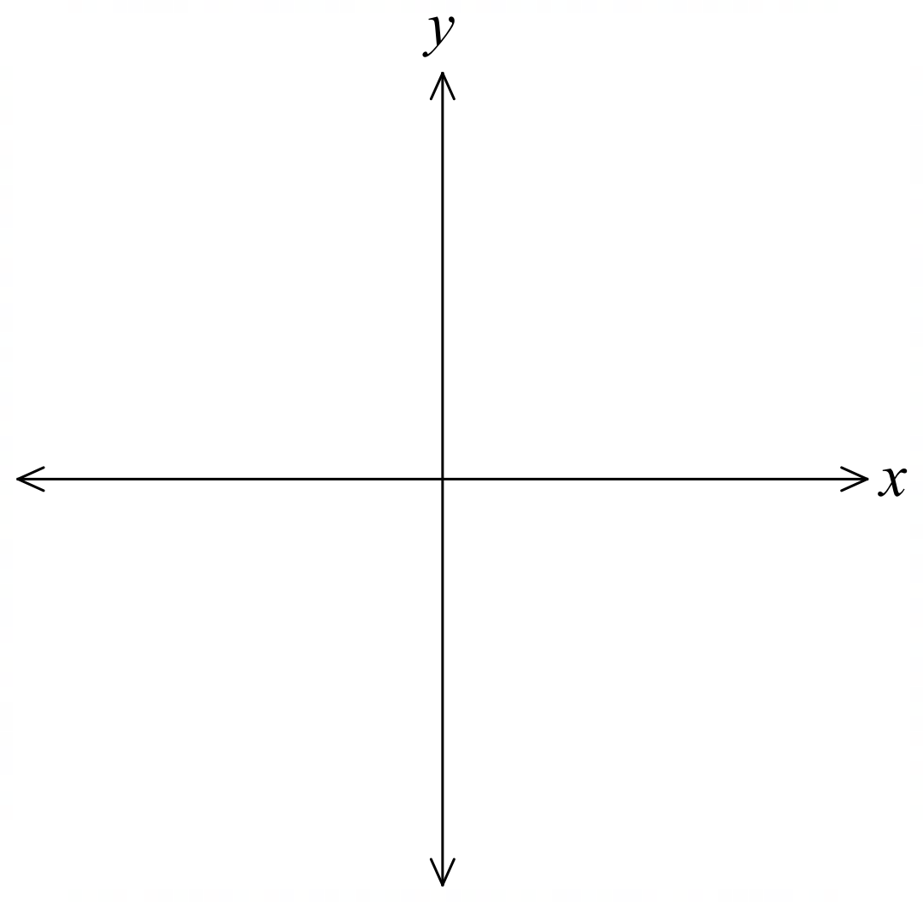

- Evaluate sum and product of zeroes.
- $P\left(x\right)=x^{3}+2x^{2}-5x-6$  Has roots $α, β, γ$. Find:  $$α+β+γ$$  $$αβ+βγ+αγ$$  $αβγ$ | - $P\left(x\right)=2x^{3}-13x^{2}+13x+10$  Has roots $α, β, γ$. Find:  $$α+β+γ$$  $$αβ+βγ+αγ$$  $αβγ$

- Factorise polynomials using factor theorem.
$$P\left(x\right)=x^{3}+2x^{2}-5x-6$$

- Identify maximum number of zeroes in a polynomial.
- $P\left(x\right)=x^{3}+2x^{2}+5$ | - $P\left(x\right)=5x^{2}-13$ | - $P\left(x\right)=x^{4}-x^{2}+2x$

- Multiplicity of Zeroes
- When a polynomial has a repeated zero (or root), we call it a zero of multiplicity.
The multiplicity tells us how many times that zero appears.

$P\left(x\right)={\left(x-a\right)}^{m}Q\left(x\right)$, $x=a$ is a zero of multiplicity $m$ of $P\left(x\right)$.

Multiplicity of zeroes tells us the behaviour of the curve at the $x$-intercepts.
$$m=1$$  The curve “cuts” the axis  like a straight line.  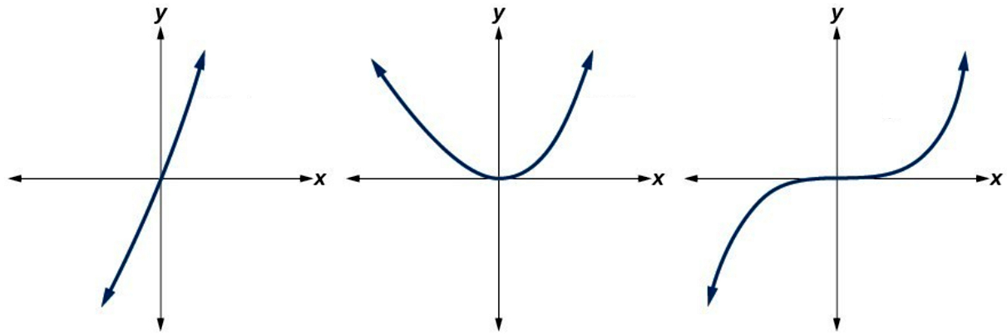 | $m≥2$, even  The curve “bounces” off  the axis like a parabola. | $m≥3,$ odd  The curve inflects along  the axis like a cubic curve.

- Interpret zeroes of multiplicity.
For each polynomial given in factored form, identify the multiplicity of the zero, and check the behaviour at the intercepts on Desmos.
- $P\left(x\right)={\left(x-5\right)}^{2}\left(x-2\right)$  $5$ is a zero of multiplicity ………  $2$ is a zero of multiplicity ……… | - $P\left(x\right)={\left(x-3\right)}^{5}{\left(x+7\right)}^{3}$  $3$ is a zero of multiplicity ………  $-7$ is a zero of multiplicity ………
- $P\left(x\right)={\left(2x-1\right)}^{3}(x+3)$  …… is a zero of multiplicity 1  …… is a zero of multiplicity 3 | - $P\left(x\right)=\left(2x-5\right){\left(x-3\right)}^{2}{\left(x+3\right)}^{120}$  $3$ is a zero of multiplicity ……  …… is a zero of multiplicity 1  …… is a zero of multiplicity 120  5 is a zero of multiplicity ……

- Multiplicity and the Derivative
- If $P\left(α\right)=0$, then $P\left(x\right)=\left(x-α\right)Q\left(x\right).$
- If $P\left(α\right)=0, P^{'}\left(α\right)=0$, then $P\left(x\right)={\left(x-α\right)}^{2}Q\left(x\right).$
- If $P\left(α\right)=0, P^{'}\left(α\right)=0$, $P^{''}\left(α\right)=0$, then $P\left(x\right)={\left(x-α\right)}^{3}Q\left(x\right).$
- If $P\left(α\right)=0, P^{'}\left(α\right)=0$, $P^{''}\left(α\right)=0$ … $P^{\left(m-1\right)}\left(α\right)=0$, then $P\left(x\right)={\left(x-α\right)}^{m}Q\left(x\right).$

- Interpret the derivative = 0 in terms of multiplicity of roots.
- If $P\left(α\right)=0$  Find an expression for $P\left(x\right).$  $$P\left(x\right)=\left(x-α\right)\left(…\right)$$ | - If $P\left(α\right)=0, P^{'}\left(α\right)=0$  Find an expression for $P\left(x\right).$
- If $P\left(α\right)=0, P^{'}\left(α\right)=0, P^{''}\left(α\right)=0$  Find an expression for $P\left(x\right).$ | - If $P\left(7\right)=0, P^{'}\left(7\right)=0$  Find an expression for $P\left(x\right).$
- If $P\left(x\right)={\left(x-α\right)}^{2}\left(…\right)$  Decide whether these will $=0$ or $≠0$  $$P\left(α\right)$$  $$P^{'}\left(α\right)$$  $$P^{''}\left(α\right)$$ | - If $P\left(x\right)={\left(x-7\right)}^{3}\left(…\right)$  Decide whether these will $=0$ or $≠0$  $$P\left(7\right)$$  $$P^{'}\left(7\right)$$  $$P^{''}\left(7\right)$$  $$P^{'''}\left(7\right)$$
- If $P\left(x\right)=\left(x-13\right)\left(…\right)$  Decide whether these will $=0$ or $≠0$  $$P\left(13\right)$$  $$P^{'}\left(13\right)$$ | - If $P\left(5\right)=0, P^{'}\left(5\right)=0, P^{''}\left(5\right)≠0$  Find an expression for $P\left(x\right).$

- Identify the multiplicity of a zero by differentiating.
It is known that $x=3$ is a zero of each of these equations.
Determine its multiplicity and confirm this with the sketch and the factorised form.
- $P\left(x\right)=x^{2}-6x+9$  $P\left(3\right)=$ ……………  $P^{'}\left(x\right)=$ …………… $P^{'}\left(3\right)=$ ………  $P^{''}\left(x\right)=$ …………… $P^{''}\left(3\right)=$ ………  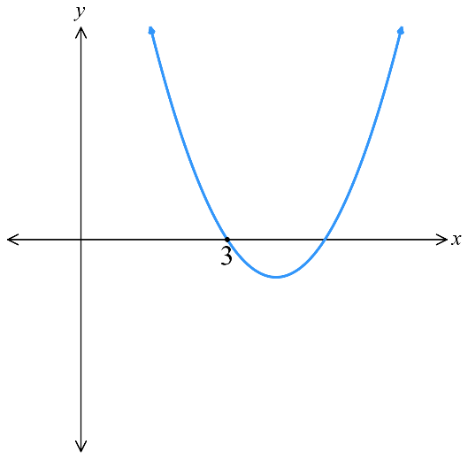  $∴3$ is a zero of multiplicity …… | 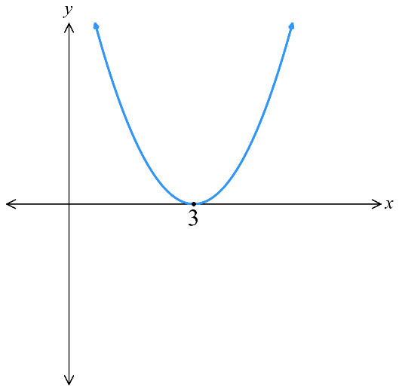  $P\left(x\right)={\left(x-3\right)}^{2}$
- $P\left(x\right)=x^{2}-8x+15$  $P\left(3\right)=$ ……………  $P^{'}\left(x\right)=$ …………… $P^{'}\left(3\right)=$ ………  $P^{''}\left(x\right)=$ …………… $P^{''}\left(3\right)=$ ………  $∴3$ is a zero of multiplicity …… | $$P\left(x\right)=\left(x-3\right)\left(x-5\right)$$
- $P\left(x\right)=x^{3}-5x^{2}+3x+9$ | $$P\left(x\right)=(x - 3)²(x + 1)$$  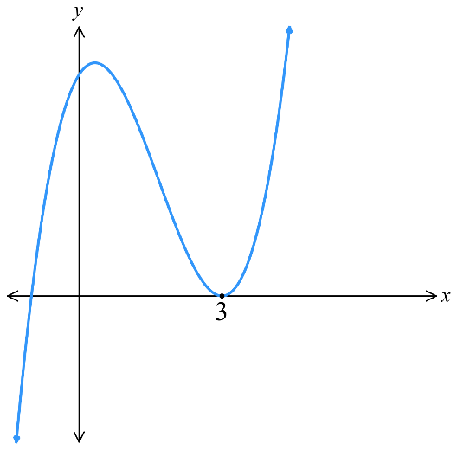
- $P\left(x\right)=x^{4}-6x^{3}+54x-81$ | $$P\left(x\right)={\left(x-3\right)}^{3}$$  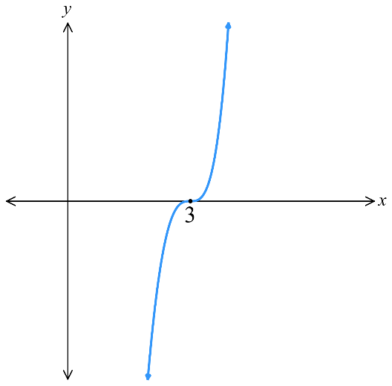

- Factorising Polynomials using Calculus
- Test factors of the constant term to find a zero.
- Test each zero in $P^{'}\left(x\right)$, $P^{''}\left(x\right)$ to find its multiplicity.
- Use sum and product of zeroes of find other zeroes.
- A polynomial of degree $n$ has at most $n$ zeroes (fundamental theorem of algebra)
- As a last resort, multiply known linear factors together and use long division.

- Example Factorise polynomials using calculus.
Factorise $P\left(x\right)=2x^{4}-7x^{3}+6x^{2}+x-2$
1. Test factors  $P\left(1\right)=0$ $∴$ factor  $$P\left(-1\right)=12$$  $P\left(2\right)=0$ $∴$ factor  $$P\left(-2\right)=108$$  2. Test multiplicity  $$P^{'}\left(x\right)=8x^{3}-21x^{2}+12x+1$$  $P^{'}\left(1\right)=0$ $∴$ $1$ is a double root.  $$P^{'}\left(2\right)=5$$  $$P^{''}\left(x\right)=24x^{2}-42x+12$$  $$P^{''}\left(1\right)=67$$  3. Find other zero using sum / product  Let roots be $1, 1, 2, α$  Sum of roots: $1+1+2+α=-$ $\frac{b}{a}$  $$4+α=\frac{7}{2}$$  $$α=-\frac{1}{2}$$  $$∴P\left(x\right)={\left(x-1\right)}^{2}\left(x-2\right)\left(2x+1\right)$$ | How do we know what numbers to use when testing factors?  These are factors of the ……………… term.  How did we know that $x=1$ is a double zero?  The d………………… is 0.  How did we know that $x=1$ is not a triple zero?  The s……………… d……………… is not 0.  How did we know that there are a maximum of four roots?  The ……………… of the polynomial is 4.  Why is this method useful when there are roots of multiplicity?  You can avoid l………… d…………… and s……………… e………………… involving sums and products of roots.

- Practice
Factorise
- $P\left(x\right)=x^{3}-3x-2$  1. Test factors  2. Test multiplicity  3. Find other zero using sum / product  $$P\left(x\right)={\left(x+1\right)}^{2}\left(x-2\right)$$ | - $P\left(x\right)=5x^{3}- 29 x^{2}+ 39 x + 9$  1. Test factors  2. Test multiplicity  3. Find other zero using sum / product  $$P\left(x\right)={\left(x-3\right)}^{2}\left(5x+1\right)$$

Foundation
- Consider the polynomial $P(x) = x³ - 4x² - 3x + 18$.
  - Show that $P(3)$ and $P'(3)$ are both zero.
P(3) = 27 - 36 - 9 + 18 = 0
P'(x) = 3x² - 8x – 3
P'(3) = 27 - 24 – 3 = 0
  - What can be deduced from the results in part a?
x = 3 is a root of multiplicity at least 2, which means (x - 3)² is a factor of P(x).
  - Hence use the sum of zeroes to find all the zeroes of $P(x)$.
Let roots be $3, 3, α$
$$3+3+α=-\frac{b}{a}$$
$$6+α=4$$
$$α=-2$$
  - Hence factor P(x).
$$P\left(x\right)={\left(x - 3\right)}^{2}\left(x + 2\right)$$
- Consider the polynomial $P(x) = x⁴ + 8x³ + 18x² + 16x + 5.$
  - Show that $P(-1)$, $P'(-1)$ and $P''(-1)$ are all zero.
P(-1) = 1 - 8 + 18 - 16 + 5 = 0
P'(x) = 4x³ + 24x² + 36x + 16
P'(-1) = -4 + 24 - 36 + 16 = 0
P''(x) = 12x² + 48x + 36
P''(-1) = 12 - 48 + 36 = 0
  - What can be deduced from the results in part a?
$x=-1$ is a root of multiplicity at least 3, so (x + 1)³ is a factor of P(x).
  - Hence use the product of zeroes to find all the zeroes of $P(x).$
Let roots be $-1,-1,-1,α$
$$-1×-1×-1×α=\frac{e}{a}$$
$$-α=5;∴α=-5$$
  - Hence factor $P(x).$
P(x) = (x + 1)³(x + 5)
- The polynomial $P(x) = x³ - 27x + 54$ has a double zero.
  - Find the zeroes of $P'(x)$.
P'(x) = 3x² - 27 = 0
x = ±3
  - Determine which of the zeroes of $P'(x)$is the double zero of $P(x)$.
P(3) = 0
P(-3) = 108 ≠ 0
So $x=3$ is a double zero.
  - Find the remaining simple zero of $P(x)$.
Let roots be $3, 3, α$
$$3+3+α=-\frac{b}{a}$$
$$6+α=0$$
$$∴α=-6$$
- The polynomial $P(x) = 2x³ + 5x² - 4x - 12$ has a double zero.
  - Find the double zero.

$$x=2$$
  - Find the remaining simple zero, and hence factor $P(x)$.

$$Remaining simple zero: \frac{3}{2}$$
$$P\left(x\right)={\left(x+2\right)}^{2}\left(2x-3\right)$$
- Let $P(x)=4x³-8x²-11x-3$.
  - Show that $x=-$ $\frac{1}{2}$ is a double root of $P(x)$.

$$P^{'}\left(x\right)=12x^{2}-16x-11$$
$$P^{'}\left(-\frac{1}{2}\right)=0$$
  - Hence, find the third root.

$$x=-3$$
- Show that if $ax^{3}+bx^{2}+cx+d=0$ has a triple root, then it must occur at $x=-$ $\frac{b}{3a}$

P'(x) = 3ax² + 2bx + c
P''(x) = 6ax + 2b
Let $P^{''}\left(x\right)=0$
$$6ax+2b=0$$
$$x=-\frac{b}{3a}$$
- The polynomial $P(x) = 8x⁴ - 28x³ + 30x² - 13x + 2$ has a triple zero.
  - Find the triple zero.
Hint: try fractions.

$$x=\frac{1}{2}$$
  - Find the remaining simple zero, and hence factor $P(x)$.

Remaining simple zero is $x=2$
$$P\left(x\right)={\left(2x-1\right)}^{3}\left(x-2\right)$$

Development
- Find the equation of the quartic polynomial equation with a triple root at $x=3$,
single root at $x = -2$and $y$-intercept $-27$.
$$P\left(x\right)=k{\left(x-3\right)}^{3}\left(x+2\right)$$
Sub in $\left(0,-27\right)$ to find $k$
$$-27=k{\left(x-3\right)}^{3}\left(x+2\right)$$
$$-27=k{\left(-3\right)}^{3}\left(2\right)$$
$$∴k=\frac{1}{2}$$
$$P\left(x\right)=\frac{1}{2}{\left(x-3\right)}^{3}\left(x+2\right)$$
- The polynomial $P(x)=px⁴+qx³-2x²+4x+6$has a double root at $x=-1$.
Find the value of $p$ and $q$.
$$P\left(-1\right)=p-q-2-4+6=0$$
$$P^{'}\left(x\right)=4px^{3}+3qx^{2}-4x+4$$
$$P^{'}\left(-1\right)=-4p+3q+4=0$$
Solving simultaneously,
$$p=q=8$$

- Consider the polynomial equation $x⁴-10x³+34x²-42x+9=0$.
  - Show that $x=3$ is a double root of the equation.
P(3) = 81 - 270 + 306 - 126 + 9 = 0
P'(x) = 4x³ - 30x² + 68x – 42
P'(3) = 108 - 270 + 204 – 42 = 0
Since both P(3) = 0 and P'(3) = 0, x = 3 is a double root.
  - Hence solve the equation.

Either by using sum & product of roots or by dividing by $x^{2}-6x+9$,
The solutions are $x=3, 2±\sqrt{3}$

- The polynomial $P(x)=x³-3x²-9x+k$ has a double zero.
  - Find the two possible values of $k$.

P'(x) = 3x² - 6x – 9 = (x - 3)(x + 1)
P'(x) = 0 when x = 3 or x = -1.
By solving $P\left(3\right)=0$ and $P\left(-1\right)=0$:
$∴k=27$ or $-5$
  - For each of the possible values of $k$, factor $P(x)$.

When $k=27, P\left(x\right)={\left(x-3\right)}^{2}\left(x+3\right)$
When $k=-5, P\left(x\right)={\left(x+1\right)}^{2}\left(x-5\right)$
- The coefficients of the polynomial $P(x)=ax³+bx+c$ are real and $P(x)$ has a multiple zero at$x=1$. When $P(x)$ is divided by $x + 1$ the remainder is $4$. Find the values of $a$, $b$ and $c$.
$$P(-1)=4$$
$$a(-1)³+b(-1)+c=4$$
$$-a-b+c=4(1)$$

$$P(1)=0$$
$$a(1)³+b(1)+c=0$$
$$a+b+c=0(2)$$

$$P'(1)=0$$
$$3a(1)²+b=0$$
$$3a+b=0$$
$$b=-3a\left(3\right)$$

$$solving simultaneously,a=1,b=-3,c=2$$
- The polynomial $P(x)=x³+6x²+9x+p$ is tangent to the $x$-axis at a point. Find the values of $p$.

Tangent to the $x$-axis means double root.
Let P(x) = 0 and P'(x) = 0
$x=-3$ or $-1$
p = 0 or 4

  - Find $b$ and $c$ if $x = 1$ is a double root of the equation $x⁴+bx³+cx²-5x+1=0.$

b = -5 and c = 8
  - Find the other roots of the equation.

$$x=\frac{3±\sqrt{5}}{2}$$

Mastery
- The equation$Ax³+Bx²+D=0$, where $A$, $B$ and $D$ are non-zero, has a double root.
  - Show that the double root is $-$ $\frac{2B}{3A}$
  - Hence show that $27A²D + 4B³ = 0$.

P'(x) = 3Ax² + 2Bx = 0
$$x(3Ax + 2B) = 0$$
$$x = 0 or x = -\frac{2B}{3A}$$
Since $P\left(0\right)≠0$, double root must occur at $x=$ $\frac{-2B}{3A}$

$$P\left(-\frac{2B}{3A}\right)= A{\left(-\frac{2B}{3A}\right)}^{3}+ B{\left(-\frac{2B}{3A}\right)}^{2}+ D = 0$$
$$-\frac{8B^{3}}{27A^{2}}+\frac{4B^{3}}{9A^{2}}+ D = 0$$
This simplifies to $27A²D + 4B³ = 0$

- The polynomial $P(x)=x⁴+px²+q$ has a double root at $x=α$.
  - Show that $x=-α$ is also a double root of $P(x)$.
  - Hence, show that $p² = 4q$.

Notice that $P\left(x\right)$ only has terms of even power, so it is an even function.
Given that $P\left(α\right)=0$, $P\left(-a\right)$ must also = $-0$as $P\left(x\right)=P\left(-x\right)$
$$P'(x) = 4x³ + 2px$$
$P^{'}\left(x\right)$ is an odd function, as it only includes terms with odd power.
Therefore if $P^{'}\left(α\right)=0,$ then $P^{'}\left(-α\right)=-P^{'}\left(a\right)=0$
Therefore, if $x=α$ is a double root, then so is $x=-α$.

$$P(x)=(x-α)²(x+α)²=x⁴-2α²x²+α⁴$$
Comparing coefficients,
$p=2α^{2}$, $q=a^{4}$
Substitute $α^{2}=\frac{p}{2}$ into $q$
$$q={\left(\frac{p}{2}\right)}^{2}$$
$$q=\frac{p^{2}}{4}$$
$$∴p^{2}=4q$$

